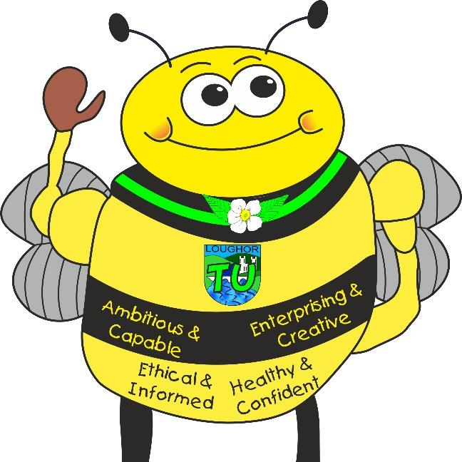
Maths and Numeracy
- Counting forwards/backwards within numbers to 20
- Counting forwards/backwards within numbers to 50
- Comparing numbers within 20
- Number bonds to 10/20
- Using number lines
- 1 more/1 less
- 2 more/2 less
- Estimation
- Doubling numbers
- Subtraction – finding the difference
- Addition
- Number problems
- Counting in groups of 10s
- Partition into 10s and 1s
- Length/height/measurement
- Measure volume/capacity/mass

Tre Uchaf Primary
Pupils, parents and teachers planning together

Memorable Experiences
Our pets – visit from Year 2 pupil with his Bearded Dragon pet
Library visit
Links to the school chosen domains

Languages, Literacy and Communication: English and Welsh Tasks
- News Circles
- Days of the week/Months of the Year and Dates in Welsh
- Discovering Wales and cities on a map
- Monster Phonics (sounds, blending & HFWs)
- Guided Reading – interpreting stories/using inference/finding facts
- Sequencing stories
- Writing sentences: punctuation; verbs; subject; adjectives
- Individual reading
- Reading out loud in front of peers
- Expressing ideas/providing feedback assessment
- Animal poetry
- Evaluating our/other’s work
- Recount text
Welsh
- Reading Welsh books
- Conversation with a friend
- Celebrating our Welsh Identity
- Nursery Rhymes

Bluebells’ Topic Map- Paws, Claws & Whiskers
Links to the 4 Purposes
Creative Bee (Enterprising Creative Contributors) – Creating a piece of Aboriginal style artwork.
Healthy Bee (Healthy confident individuals) – Listening to others; expressing personal opinion regarding friendship.
Community Bee (Ethical and Informed citizens) – Caring for animals; locating animals around the world; Should animals be kept in a zoo? Losar - Buddhism
Learning Bee (Ambitious and capable learners) – Innovate topic challenge (bringing skills together to solve a mystery including categorising, classification, data analysis and report writing.)

Ambitious, Capable Learners who are ready to learn throughout their lives
Healthy, Confident Individuals ready to lead fulfilling lives as valued members of society
Enterprising, Creative Contributors who are ready to play a full part in life and work
Ethical, Informed Citizens of Wales and the World
Health and Well-Being Activities
- Demonstrate fitness - develop and apply their ball chasing and floor work balance.
- Animal movements; Dance
- Caring for animals
- Learning about friendships
- Comment on their own or others' performance, routine or game.
- Participate in simple playground games, following the rules.
- Develop vocabulary to describe feelings – Zones of Regulation.
- Learn to recognise that there are things that they can do to help when finding things difficult.
- Identify times when people are unkind and understand how to respond, including online.
- Listen to other people and play and work cooperatively.
- Talking and responding to positive play.
- Mindfulness
- Yoga

Science and Technology Activities

- E-safety
- Classification- How are we/animals different and the same?
- Gather data – tally charts
- Create a pictogram
- What is camouflage for?
- Water activities – measurement, heavier/lighter, volume and capacity.
- Coding using JIT/Beebots
- iPad work

Expressive Arts Activities
- Line drawing
- Pattern creating oil pastels
- Using natural materials to create an animal
- Painting
- Singing/Practicing rhymes and poetry
- Role play
- Collages
- Model making
- Dot art

- Experimenting with colours
Healthy, Confident Individuals ready to lead fulfilling lives as valued members of society
Enterprising, Creative Contributors who are ready to play a full part in life and work
Ambitious, Capable Learners who are ready to learn throughout their lives
Ethical, Informed Citizens of Wales and the World
Humanities Activities
- Losar – Buddhism
- Describe what they have found out about people, beliefs and questions and offer simple explanations.
- Observe and recount different ways of expressing identity and belonging, responding sensitively for themselves.
- Understand that other people have feelings and beliefs that affect the way they think and behave.
- Using and making maps.
- Describing physical features.
- Identify the similarities and differences between two animals.
- Name and locate the four countries of the UK and their capital cities on a map, atlas or globe.
- Locate hot and cold areas of the world and what animals live there.
- Recognise that people and other living things have rights.
- Demonstrate care, respect and affection for other children, adults, other living things and their environment.
- Develop a growing interest in the world around them and develop understanding and responsibility for living things and the environment.
- RSE - Ten Little Pirates – To play with boys and girls
- Use Google Earth
- Languages from countries around the world
- Woodland games

