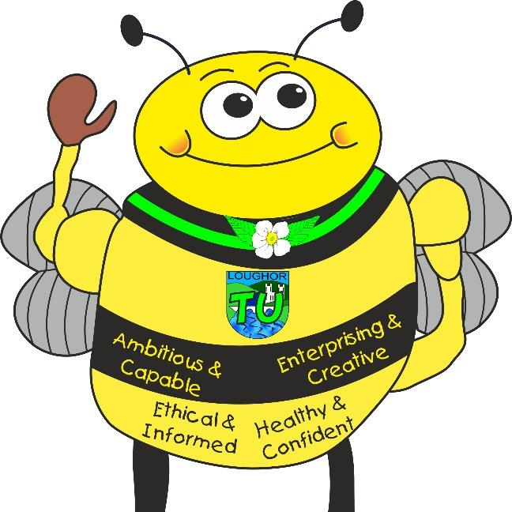
Languages, Literacy and Communication: English and Welsh Tasks
Languages, Literacy and Communication: English and Welsh Tasks
- POPAT • Monster Phonics
- News circles • Sharing daily stories
- Recount Writing Reading with an adult
- Rhymes and mnemonics
- Listening to stories • Descriptions
• Days of the week/weather in Welsh songs
• News of weekend • Family – Dyma Tedi Twt Dyma teulu Teddi Twt
- Instruction writing
• Creating a comic strip
- Presenting to an audience

Tre Uchaf Primary
Pupils, parents and teachers planning together
Memorable Experiences
Visit from the Fire Service
Links to the school chosen domains
Visits from emergency services, guest speakers
Understanding the local community, its history, environment and its everyday ‘heroes’
Maths and Numeracy
- Place Value
- Counting objects
- Counting on from a given number
- Counting backwards from 10
- 1 more, 1 less
- Using a number line
- Less than, greater than, equal to
- Comparing numbers
- Parts and wholes
- Number bonds to 10
- Addition
- Subtraction

Year 1/Rec Topic Map- Superheroes
Links to the 4 Purposes
Creative Bee- Enterprising Creative Contributors- Creating a Superhero name and scene
Healthy Bee-Healthy, Confident Individuals- Looking at healthy foods that fuel our bodies. Growing and nurturing a sunflower from seed.
Community Bee-Ethical, Informed Citizens- Understanding and visiting our community ‘Superheroes’.
Learning Bee- Ambitious, capable learners- EPIC planning. Growth mindset. Displaying resilience and determination when facing challenges.

Ambitious, Capable Learners who are ready to learn throughout their lives
Healthy, Confident Individuals ready to lead fulfilling lives as valued members of society
Enterprising, Creative Contributors who are ready to play a full part in life and work
Ethical, Informed Citizens of Wales and the World
Health and Well-Being Activities
- Mindfulness techniques
- Teamwork games
- Traditional games
- Sharing memories
- Playing and working cooperatively
- Creating a healthy soup
- Team games during PE.
- Outdoor learning – Woodland Wednesdays
- Identify special people, what makes them special and how they should be treated
- Focusing on kindness and respect to others

Science and Technology Activities

• Making a soup
• Using different IT programmes to create and design
• Planting and nurturing bulbs
• Use an iPad to take photos
• Observe objects, materials, living things and changes over time, sorting and grouping them based on their features
- Learning how to stay safe online
- Draw and label the main parts of the human body and say which body part is associated with which sense
- follow instructions to perform simple tests and begin to talk about what they might do or what might happen

Humanities Activities
- Discover real life superheroes of the past
- Describe how they can contribute to the life of the class and school
- Looking at how we can support our environment
- Listening to appropriate Newsround stories and learning about contemporary news
- RSE – Elmer – to like the way I am
- RE – Sikhism (Anand Karaj)
- Looking at our local environment

Expressive Arts Activities
- Creating a collage – Superhero city
- Using various art media to create Superhero art displays
- Sequencing Superhero movements
- Using percussion to add to a sequence of movements
- Explore the properties of materials to create a superhero model
- Role play in the Superhero corner
- Film Fortnight – Growth Mindset

Healthy, Confident Individuals ready to lead fulfilling lives as valued members of society
Enterprising, Creative Contributors who are ready to play a full part in life and work
Ambitious, Capable Learners who are ready to learn throughout their lives
Ethical, Informed Citizens of Wales and the World

