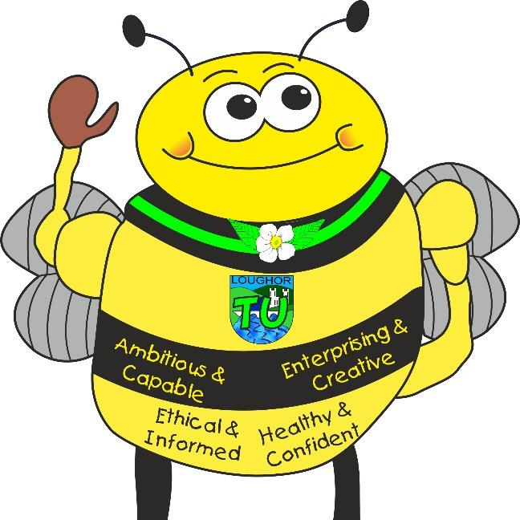
Languages, Literacy and Communication: English and Welsh Tasks
Languages, Literacy and Communication: English and Welsh Tasks
• News circles
- Sharing daily stories
- Diary entry writing
• Rhymes and mnemonics • Months of the year
• Information texts Cymraeg • Days of the week in Welsh song
• News of weekend • Family – Dyma Tedi Twt Dyma teulu Teddi Twt • Making a memory – Beth sy’n yn y bocs?
• Recognising Wales on a map and cities/towns • Monster Phonics
within Gogledd, Dwyrain, De, Gorllewin Gymru
- Story map writing
- Creating a class song
- Sentence construction
- Library visits

Tre Uchaf Primary
Pupils, parents and teachers planning together
Memorable Experiences
Visit from former pupils – school in the 1940’s/50s & 60s/70s
Walk around the school – What has changed?
Links to the school chosen domains
Visit from former pupil
Understanding the local community, area and its history
Maths and Numeracy
• be able to recite numbers to 100 ​
• To count in 2’s, 5’s and 10’s to 50. ​
• To count backwards from 20 + ​

• Add ones using number bonds
• To read and write numbers to at least 20. ​
• Use number facts within 10 (bonds to 10). ​

Find and make number bonds to 20
Answer simple addition and subtraction sums. ​

Subtraction - finding the difference
Read and write number words to 10 ​

• Related facts
Find totals and give change from 10p ​
• Doubling. ​
My Money Week

Year 1/Rec Topic Map- Memory Box
Links to the 4 Purposes
Creative Bee- Enterprising Creative Contributors- Making family portraits from different art resources. .
Healthy Bee-Healthy, Confident Individuals- Planning and preparing a healthy meal.
Community Bee-Ethical, Informed Citizens- Changes in our communities. Caring for those around us.
Learning Bee- Ambitious, capable learners- EPIC planning. Growth mindset. Displaying resilience and determination when facing challenges.

Ambitious, Capable Learners who are ready to learn throughout their lives
Healthy, Confident Individuals ready to lead fulfilling lives as valued members of society
Enterprising, Creative Contributors who are ready to play a full part in life and work
Ethical, Informed Citizens of Wales and the World
Health and Well-Being Activities
• Dance Families to come into class
• Mindfulness techniques
• Teamwork games Daily exercise
• Traditional games
• Caring for babies and toddlers
• Sharing memories
• Playing and working cooperatively
• Making healthy meals/snacks
• Sport’s Day races/field activities

• Team games/ school games.
• Outdoor learning – woodland activities

•
Science and Technology Activities

• Making foods
Tasting foods
• Learning about the five senses - Drawing and labelling the main parts of the human body and saying which body part is associated with which sense.
• Celebration cards -Selecting and using a range of materials, beginning to explain their choices.
• Making a memory box
• Working scientifically
Cooking
Practical science investigations - water
Humanities Activities
• Comparing locality now and in the past
• Map work
• Changes within living memory
• How can historical photos, objects and documents help us to understand the past?
• Differences between now and the past in everyday life; How we shopped, what we played how people did chores.

Use of Google Earth
Play with traditional/past time toys

Expressive Arts Activities
• Making family portraits using paints, collage and drawing
• Creating celebration cards
• Songs that help us remember
• Writing our own class song
• Dance - Copying, creating and remembering simple movement patterns, showing awareness of rhythm.
Creating a portrait using natural materials

Portrait using different art media we haven’t used before
More role-playing
Healthy, Confident Individuals ready to lead fulfilling lives as valued members of society
Enterprising, Creative Contributors who are ready to play a full part in life and work
Ambitious, Capable Learners who are ready to learn throughout their lives
Ethical, Informed Citizens of Wales and the World

