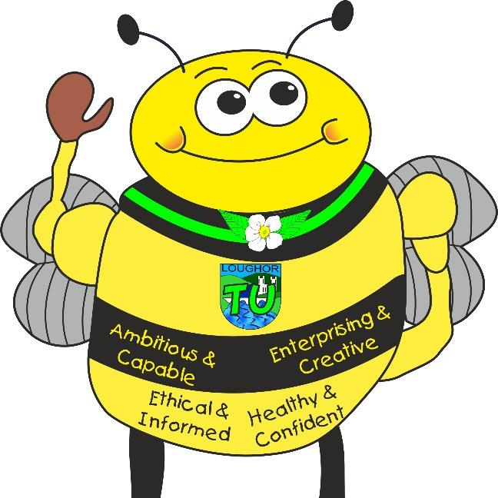
Languages, Literacy and Communication: English and Welsh Tasks
- Non-chronological reports- reports about something we are deeply interested in.
- Adverts- Persuasive writing/ Creating web pages and tag-lines
- Facts, opinions and tributes – talking about ourselves and others
- Character roles – Film project, in depth exploration of characters in film
- Calligrams or shape poems
- Biography – link to Black History
- Class debates
- Write about ourselves , poetry
- Newsround guided reading activities
- Fact files – what is of interest to us personally
- Modern Foreign Languages, language of the month, pupils ideas and interests.
- Story writing for Buzz’s Missions
Welsh
- Personal profile ‘Dyma Fi’ (‘This is Me’)
- Monday Diary entry every (Dyddiadur Dydd Llun)
- Conversation with a friend, role plays Write Fact Files in Welsh
- Celebrating our Welsh Identity, Proud to be Welsh.
- Linguascope Welsh, Welsh spoken for dinner registers, Helpur Heddiw to decided theme for regis

Year 6 Topic Map - Identity
Who am I and what makes me this way?
Maths and Numeracy
- Place value numbers up to 10,000,000
- Compare and order numbers
- Rounding numbers to 10, 100, 1000
- Negative numbers
- Add and subtract numbers with more than 4 digits also decimals (money) Civil’s Cafe
- Inverse operations
- Multi step addition and subtraction problems
- Multiplications (consolidation of times tables facts and written methods for larger multiplications).
- Divide with remainders , Short and Long division
- Common factors and multiples, prime numbers to 100, squares and cubes Civil’s Chocolate Factory.
- Equivalent and improper fractions link simple fractions to percentages My Piedentity
- Add and subtract fractions and mixed numbers
- Geometry- position and direction Design my Perfect House
- Data Analysis – comparing data collected looking for patterns and trends Vitruvian Man link to Science and PE lessons.
- Comparing heights and lengths of different body parts, Mathematical technology – old and new
- Numbers in different languages, Pi’line Art, Class data games, Measures link to medicine, recipes,

Tre Uchaf Primary
Pupils, parents and teachers planning together

Memorable Experiences
Techniquest – Santa’s Spy Squad
Forensic investigation in the Lab
Links to the school chosen domains

Links to the 4 Purposes
Creative Bee (Enterprising Creative Contributors) - Design and make or remodel a simple item of clothing. Create an Avatar using digital technology.
Healthy Bee (Healthy confident individuals) – Active journeys, healthy minds, bodies and diets. Healthy cooking, outdoors learning in yard, field and woodland areas.
Community Bee (Ethical and Informed citizens) – Pupil voice elections. Black history month. Children in Need organisation, fund raising for charity at Christmas fayre.
Learning Bee (Ambitious and capable learners) – Innovate topic challenge (bringing skills together to solve a mystery including measurement, classification, data analysis and report writing.) Aspirations week. Work on developing a Growth Mind-set.

Ambitious, Capable Learners who are ready to learn throughout their lives
Healthy, Confident Individuals ready to lead fulfilling lives as valued members of society
Enterprising, Creative Contributors who are ready to play a full part in life and work
Ethical, Informed Citizens of Wales and the World
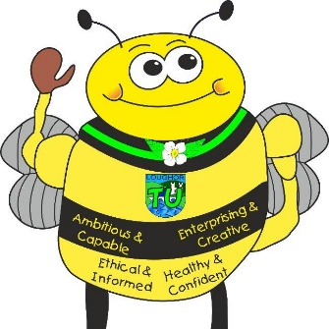
Health and Well-Being Activities
- Physical challenges, Invasion Games and Team Building challenges
- Identity, personal views and opinions; My place; Recognising strengths
- The impact of human behaviour in our locality
- Staying healthy, diet and nutrition, mindful habits and growth mind-set.
- Daily Ks,
- Children In Need organise physical activities, stalls, wellbeing activities
- How do we learn? Different learning styles
- Women’s sports
- Food across the centuries
- Research famous athletes and their diets, habits,
- Healthy foods and our teeth,
- Growing our own food (Peace Gardening)
- Field – litter picks and adopt a tree.
- Compare diets through the ages and across the world.

Science and Technology Activities
- E-safety
- Classification- Why are things classified investigation.
- How does inheritance work? Investigation
- Fingerprint facts
- Inheritance, genetics and characteristics with links to Darwin
- Design and make or remodel a simple item of clothing
- Create an Avatar using digital technology
- Artificial intelligence and Robotics
- Minecraft education
- Exploring diversity through Science – e.g skittle experiment
- Looking at the building blocks of things, dismantle objects and re build
- Homework to make favourite food
- 3D print DNA helix
- Link to Penyrheol Science – Mr Grey Experiments

Humanities Activities
- Identity, Family and Community
- Family trees, exploring our roots,
- Mapping out our identity
- Social reformers/Influential historical figures
- Pupil voice presentations and elections
- Celebrating Black History
- Judaism – Passover and Rosh Hashanah Yom Kippur
- Christianity at Christmas
- Explore the different religious beliefs of pupils in class.
- Family history other people’s ancestors
- Where the word identity comes from
- Countries of the world, maps, identities around the world, cultural identity
- Exploring identities of others in different times and circumstances.

Expressive Arts Activities
- Portraits, profiles, silhouettes,
- Skin tone and colour mixing
- Perspective drawing – Christmas Cards – water colours
- Listening to voices and lyrics
- Musical notation and music choices – likes and dislikes
- Design; Fashion and clothing – sustainability issues
- Creative Dance – All about me and Robotic movement exploration
- Looking at the work of Jean – Michel Basquiat
- String Art inspired by our DNA
- Art from another country – Artists from other countries,
- Drawing the essence of our emotions
- Zodiac signs
- Our interests, merge into mix- match forms.
- Portraits using realistic techniques and mixed media such as pens, collage, etc.
- Future us sketches of our grown up selves
- Pop Art, Hand prints, finger prints, eye pictures with detail inside of a future you.

Healthy, Confident Individuals ready to lead fulfilling lives as valued members of society
Enterprising, Creative Contributors who are ready to play a full part in life and work
Ambitious, Capable Learners who are ready to learn throughout their lives
Ethical, Informed Citizens of Wales and the World

