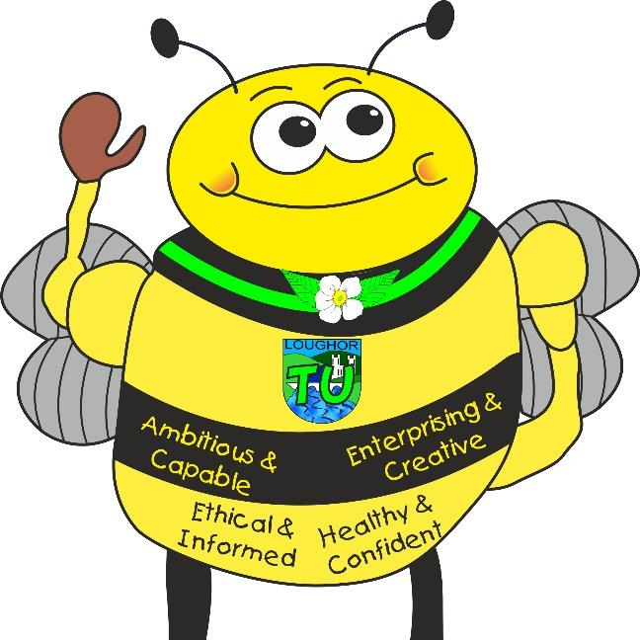
Languages, Literacy and Communication: English and Welsh Tasks
Languages, Literacy and Communication: English and Welsh Tasks
• Monster Phonics – Phoneme/Grapheme/Blending
• News circles • Sharing daily stories
• Reading and writing diaries
• Rhymes and mnemonics • Descriptions
• Information texts Cymraeg • Days of the week in Welsh song
• News of weekend
• Welsh – days of the week, numbers to 20
• Creating a comic strip

- Non – fiction writing • Writing a fact file
- Hot seating a Superhero/villain
Presenting to an audience
- Write a comic strip
- Read comic strips

Tre Uchaf Primary
Pupils, parents and teachers planning together
Memorable Experiences
Visit from the Fire Service
Walk to Loughor estuary
Links to the school chosen domains
Visits from emergency services, guest speakers
Understanding the local community, its history, environment and its everyday ‘heroes’
Maths and Numeracy
- Sorting objects
- Counting objects
- Representing objects from a larger group
- Represent objects
- Recognise numbers as words
- Counting on from any number
- 1 more, 1 less

Count backwards within 10
- ​Compare groups by matching
- Fewer, more, same
- Less than, greater then, equal to
- Compare numbers • The number line
- Compare objects and numbers
- Bake and sell cakes

Bluebells Topic Map- Superheroes
Links to the 4 Purposes
Creative Bee- Enterprising Creative Contributors- Creating a Superhero name and scene
Healthy Bee-Healthy, Confident Individuals- Looking at healthy foods that fuel our bodies. Growing and nurturing a sunflower from seed.
Community Bee-Ethical, Informed Citizens- Understanding and visiting our community ‘Superheroes’.
Learning Bee- Ambitious, capable learners- EPIC planning. Growth mindset. Displaying resilience and determination when facing challenges.

Ambitious, Capable Learners who are ready to learn throughout their lives
Healthy, Confident Individuals ready to lead fulfilling lives as valued members of society
Enterprising, Creative Contributors who are ready to play a full part in life and work
Ethical, Informed Citizens of Wales and the World
Health and Well-Being Activities
- Dance and song
- Mindfulness techniques
- Teamwork games
- Traditional games
- Sharing memories
- Playing and working cooperatively
- Creating a healthy soup
- Team games during PE.
- Outdoor learning – woodlands
- Identify special people, what makes them special and how they should be treated
- Focusing on kindness and respect to others

Science and Technology Activities

• Investigation- rocket shooting
• Investigation- potions
• Making a soup
• Using different IT programmes to create and design
• Weekly mini science experiments
• Use an iPad to take photos
• Observe objects, materials, living things and changes over time, sorting and grouping them based on their features
- Learning how to stay safe online
- Draw and label the main parts of the human body and say which body part is associated with which sense
- follow instructions to perform simple tests and begin to talk about what they might do or what might happen

Humanities Activities
- Discover real life superheroes of the past
- Describe how they can contribute to the life of the class and school
- Looking at how we can support our environment
- Visiting our local estuary
- Listening to appropriate Newsround stories and learning about contemporary news
- RSE - To recognise that people are different ages
- RE – Christianity (Harvest)
- Learn about the history of Superheroes in our communities
- Learn about our ‘Everyday Heroes’
Expressive Arts Activities
- Creating a collage – Superhero city
- Using various art media to create Superhero art displays
- Sequencing Superhero movements
- Using percussion to add to a sequence of movements
- Hot seating a superhero/villain
- Role play in the Superhero corner
- Creating a wanted poster for a villain
- Create a theme of music
- Superhero collage
- Superhero theme tune

Healthy, Confident Individuals ready to lead fulfilling lives as valued members of society
Enterprising, Creative Contributors who are ready to play a full part in life and work
Ambitious, Capable Learners who are ready to learn throughout their lives
Ethical, Informed Citizens of Wales and the World

